**Lily Williams**

**Python Developer**

**+359 88 888 8888**

**help@enhancv.com**

**github.io/lily.williams**

**San Francisco, CA**

**SUMMARY**

Python developer with 8 years of experience in finance and fintech. Well-acquainted with database engineering, data warehouses, and data processing. Knowledgeable in Python frameworks related to data such as SciPy, NumPy, Matplotlib. Cloudera certified Data analyst, PCPP-1 certification and Spark/Hadoop developer certification.

**EDUCATION**

B.S. Software Engineering**University of California, San Fransisco**

[**2008 - 2012**](https://enhancv.com/resume-examples/python-developer/)

San Francisco, CA

GPA

**3.8** / 4.0

**EXPERIENCE**

Python Developer**Revolut**

[**2015 - 2018**](https://enhancv.com/resume-examples/python-developer/)

San Francisco, CA

Revolut is a financial technology company that offers banking services. We offer accounts featuring currency exchange, debit cards, virtual cards, and vaults.

Collaborated with Web Application Engineers, used Python scripts to load the data into AWS Cloud Cassandra database

Visualised over 40 datasets with Matplotlib

Involved in processing the streaming data as well as batch data using Apache Spark

Delivering projects with 1-2 days turn around time or even within hours

Python Developer**Bank of America**

[**2012 - 2015**](https://enhancv.com/resume-examples/python-developer/)

San Francisco, CA

Lauzon is a finance firm based out of San Fransisco, CA. They cater to many local businesses and startups by providing custom finance software.

Developed internal tools for text mining (sentimental analysis), and web crawler for collecting data by Python and SQL

Used AWS Elastic Beanstalk service for deploying and scaling web applications and services developed with Java, Python

Developed shell scripting and Python programs to automate the data flow on day-to-day tasks

Analyzed the SQL scripts and designed the solution to Developed a custom ETL pipeline by using Python

Junior Python Developer**Streich**

[**2018 - ONGOING**](https://enhancv.com/resume-examples/python-developer/)

San Francisco, CA

Lauzon is a finance firm based out of San Fransisco, CA. They cater to many local businesses and startups by providing custom finance software.

Made over 800 insertions and 150 deletions to 4 central Firmware repositories in less than 3 months

Participated in more than 4 projects per year from initial research and conceptual design through testing and implementation phases

Developed data quality portal using Python scripting, increasing data quality by 30%

Communicated and coordinated with the project manager and coworkers to resolve 30+ build breaks a month

**SKILLS**

Programming

**PythonSciPyNumPyMatplotlibDjangoFlaskSQLJava**

Databases & Servers

**AWSDjango ORMMySQLETLCassandraMongoDBHadoopSpark**

Development

**GITSVNPyCharm**

**CERTIFICATION**

**CCA Data AnalystCloudera**, 2017

**CCA Spark and Hadoop DeveloperCloudera**, 2015

**PCPP1The Python Institute**, 2014

**STRENGTHS**

**Time management**

Prioritizes essential tasks so they are not rushed. Sets deadlines that ensure reaching milestones on time.

**Adaptability**

I remember that change is not personal and is inevitable. I break my projects into multiple parts so that if something goes wrong, I can quickly fix it.

**Accountability**

I take ownership of my mistakes. By doing that I learn what I did wrong so that it does not happen again.

www.enhancv.com

Powered by



Your dream job awaits, make your move.

Create the best version of your Python Developer resume.

[**USE THIS TEMPLATE**](https://app.enhancv.com/resume/new?example=python-developer)

[Resume Builder](https://enhancv.com/resume-builder/)

[Resume Examples](https://enhancv.com/resume-examples/)

[Resume Templates](https://enhancv.com/resume-templates/)

[Resume Skills](https://enhancv.com/resume-skills/)

[**Build your resume**](https://app.enhancv.com/)

[](https://enhancv.com/)

[](https://enhancv.com/fr/)

[](https://enhancv.com/se/)

[Resume Writing](https://enhancv.com/career-counseling#ccs-resume-write)

[Resume Review](https://enhancv.com/career-counseling#ccs-resume-review)

[LinkedIn Revamp](https://enhancv.com/career-counseling#ccs-linkedin-revamp)

[Cover Letter Writing](https://enhancv.com/career-counseling#ccs-cover-letter-write)

[Job Search](https://enhancv.com/career-counseling#ccs-job-search)

[Interview Prep](https://enhancv.com/career-counseling#ccs-interview-prep)

[Compensation Negotiation](https://enhancv.com/career-counseling#ccs-negotiation)

[Executive Bio](https://enhancv.com/career-counseling#ccs-exec-bio)

[Packages](https://enhancv.com/career-counseling/)

[Meet our customers](https://enhancv.com/career-counseling/jenica-success-story/)

[**Book an intro call**](https://calendly.com/career-counseling-services/enhancv-intro-call)

* [Resume](https://enhancv.com/resume-examples/)
* [Cover Letter](https://enhancv.com/cover-letter-examples/)
* [Career Counseling](https://enhancv.com/career-counseling/)
* [Resources](https://enhancv.com/resources/)
* [Pricing](https://enhancv.com/pricing/)
* [ English](https://enhancv.com/resume-examples/python-developer/#language-menu)
* [Sign in](https://app.enhancv.com/login)
* [Get started](https://app.enhancv.com/)

Your dream job awaits, make your move.

Create the best version of your Python Developer resume.

[**USE THIS TEMPLATE**](https://app.enhancv.com/resume/new?example=python-developer)

**Lily Williams**

**Python Developer**

**+359 88 888 8888**

**help@enhancv.com**

**github.io/lily.williams**

**San Francisco, CA**

**SUMMARY**

Python developer with 8 years of experience in finance and fintech. Well-acquainted with database engineering, data warehouses, and data processing. Knowledgeable in Python frameworks related to data such as SciPy, NumPy, Matplotlib. Cloudera certified Data analyst, PCPP-1 certification and Spark/Hadoop developer certification.

**EDUCATION**

B.S. Software Engineering**University of California, San Fransisco**

[**2008 - 2012**](https://enhancv.com/resume-examples/python-developer/)

San Francisco, CA

GPA

**3.8** / 4.0

**EXPERIENCE**

Python Developer**Revolut**

[**2015 - 2018**](https://enhancv.com/resume-examples/python-developer/)

San Francisco, CA

Revolut is a financial technology company that offers banking services. We offer accounts featuring currency exchange, debit cards, virtual cards, and vaults.

Collaborated with Web Application Engineers, used Python scripts to load the data into AWS Cloud Cassandra database

Visualised over 40 datasets with Matplotlib

Involved in processing the streaming data as well as batch data using Apache Spark

Delivering projects with 1-2 days turn around time or even within hours

Python Developer**Bank of America**

[**2012 - 2015**](https://enhancv.com/resume-examples/python-developer/)

San Francisco, CA

Lauzon is a finance firm based out of San Fransisco, CA. They cater to many local businesses and startups by providing custom finance software.

Developed internal tools for text mining (sentimental analysis), and web crawler for collecting data by Python and SQL

Used AWS Elastic Beanstalk service for deploying and scaling web applications and services developed with Java, Python

Developed shell scripting and Python programs to automate the data flow on day-to-day tasks

Analyzed the SQL scripts and designed the solution to Developed a custom ETL pipeline by using Python

Junior Python Developer**Streich**

[**2018 - ONGOING**](https://enhancv.com/resume-examples/python-developer/)

San Francisco, CA

Lauzon is a finance firm based out of San Fransisco, CA. They cater to many local businesses and startups by providing custom finance software.

Made over 800 insertions and 150 deletions to 4 central Firmware repositories in less than 3 months

Participated in more than 4 projects per year from initial research and conceptual design through testing and implementation phases

Developed data quality portal using Python scripting, increasing data quality by 30%

Communicated and coordinated with the project manager and coworkers to resolve 30+ build breaks a month

**SKILLS**

Programming

**PythonSciPyNumPyMatplotlibDjangoFlaskSQLJava**

Databases & Servers

**AWSDjango ORMMySQLETLCassandraMongoDBHadoopSpark**

Development

**GITSVNPyCharm**

**CERTIFICATION**

**CCA Data AnalystCloudera**, 2017

**CCA Spark and Hadoop DeveloperCloudera**, 2015

**PCPP1The Python Institute**, 2014

**STRENGTHS**

**Time management**

Prioritizes essential tasks so they are not rushed. Sets deadlines that ensure reaching milestones on time.

**Adaptability**

I remember that change is not personal and is inevitable. I break my projects into multiple parts so that if something goes wrong, I can quickly fix it.

**Accountability**

I take ownership of my mistakes. By doing that I learn what I did wrong so that it does not happen again.

www.enhancv.com

Powered by

[Enhancv](https://enhancv.com/) > [Resume Examples](https://enhancv.com/resume-examples/) > > Python Developer Resume

**Professional Python Developer Resume Examples & Guide for 2021**

Customize this resume with ease using our seamless online resume builder.

[**USE THIS EXAMPLE**](https://app.enhancv.com/resume/new?example=python-developer)

[Learn‌ ‌how‌ ‌to‌ ‌create‌ ‌the‌ ‌perfect‌ Python Developer resume](https://enhancv.com/resume-examples/python-developer/#article)

**Lily Williams**

**Python Developer**

**+359 88 888 8888**

**help@enhancv.com**

**github.io/lily.williams**

**San Francisco, CA**

**SUMMARY**

Python developer with 8 years of experience in finance and fintech. Well-acquainted with database engineering, data warehouses, and data processing. Knowledgeable in Python frameworks related to data such as SciPy, NumPy, Matplotlib. Cloudera certified Data analyst, PCPP-1 certification and Spark/Hadoop developer certification.

**EDUCATION**

B.S. Software Engineering**University of California, San Fransisco**

[**2008 - 2012**](https://enhancv.com/resume-examples/python-developer/)

San Francisco, CA

GPA

**3.8** / 4.0

**EXPERIENCE**

Python Developer**Revolut**

[**2015 - 2018**](https://enhancv.com/resume-examples/python-developer/)

San Francisco, CA

Revolut is a financial technology company that offers banking services. We offer accounts featuring currency exchange, debit cards, virtual cards, and vaults.

Collaborated with Web Application Engineers, used Python scripts to load the data into AWS Cloud Cassandra database

Visualised over 40 datasets with Matplotlib

Involved in processing the streaming data as well as batch data using Apache Spark

Delivering projects with 1-2 days turn around time or even within hours

Python Developer**Bank of America**

[**2012 - 2015**](https://enhancv.com/resume-examples/python-developer/)

San Francisco, CA

Lauzon is a finance firm based out of San Fransisco, CA. They cater to many local businesses and startups by providing custom finance software.

Developed internal tools for text mining (sentimental analysis), and web crawler for collecting data by Python and SQL

Used AWS Elastic Beanstalk service for deploying and scaling web applications and services developed with Java, Python

Developed shell scripting and Python programs to automate the data flow on day-to-day tasks

Analyzed the SQL scripts and designed the solution to Developed a custom ETL pipeline by using Python

Junior Python Developer**Streich**

[**2018 - ONGOING**](https://enhancv.com/resume-examples/python-developer/)

San Francisco, CA

Lauzon is a finance firm based out of San Fransisco, CA. They cater to many local businesses and startups by providing custom finance software.

Made over 800 insertions and 150 deletions to 4 central Firmware repositories in less than 3 months

Participated in more than 4 projects per year from initial research and conceptual design through testing and implementation phases

Developed data quality portal using Python scripting, increasing data quality by 30%

Communicated and coordinated with the project manager and coworkers to resolve 30+ build breaks a month

**SKILLS**

Programming

**PythonSciPyNumPyMatplotlibDjangoFlaskSQLJava**

Databases & Servers

**AWSDjango ORMMySQLETLCassandraMongoDBHadoopSpark**

Development

**GITSVNPyCharm**

**CERTIFICATION**

**CCA Data AnalystCloudera**, 2017

**CCA Spark and Hadoop DeveloperCloudera**, 2015

**PCPP1The Python Institute**, 2014

**STRENGTHS**

**Time management**

Prioritizes essential tasks so they are not rushed. Sets deadlines that ensure reaching milestones on time.

**Adaptability**

I remember that change is not personal and is inevitable. I break my projects into multiple parts so that if something goes wrong, I can quickly fix it.

**Accountability**

I take ownership of my mistakes. By doing that I learn what I did wrong so that it does not happen again.

www.enhancv.com

Powered by

Example Python Developer Resume - [**Browse more resume templates and build a stand-out resume**](https://enhancv.com/resume-templates/)



**Volen Vulkov**

8 minute read

Updated on 2021-08-10

Table of contents

When a recruiter or a CTO looks at a python resume, their first instinct is to ensure they separate “wheat from chaff”.

A badly written resume can leave an impression that you are a Python dev who learned Python from a “Learn Python in 24 hours” book, and actually finished it in less than 24 hours.

But don’t worry, with these Python resume examples and our extensive guide, you’ll be able to write your Python resume as if you were Guido Van Rossum.

In this guide, you’ll see:

* 3 Python developer resume examples that would land a job every time
* How to add projects, resume skills and object on your resume
* How to put your resume experience and achievements on your resume
* Convert applications to more job interviews by writing the perfect Python resume

**Here are 3 amazing Python resume examples**

Entry level Python developer resume

[**USE THIS TEMPLATE**](https://app.enhancv.com/resume/new?example=python-developer_entry-level-python-developer)

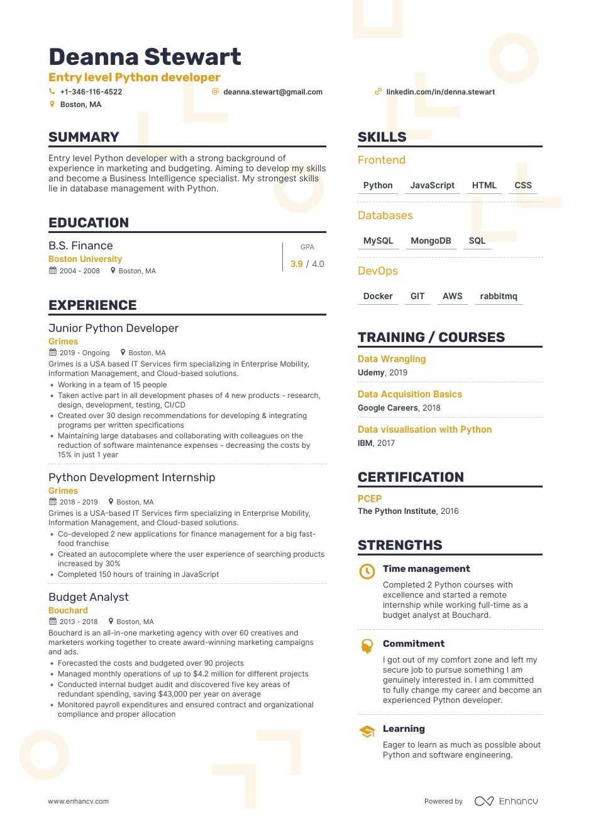

Senior Python developer resume

[**USE THIS TEMPLATE**](https://app.enhancv.com/resume/new?example=python-developer_senior-python-developer)

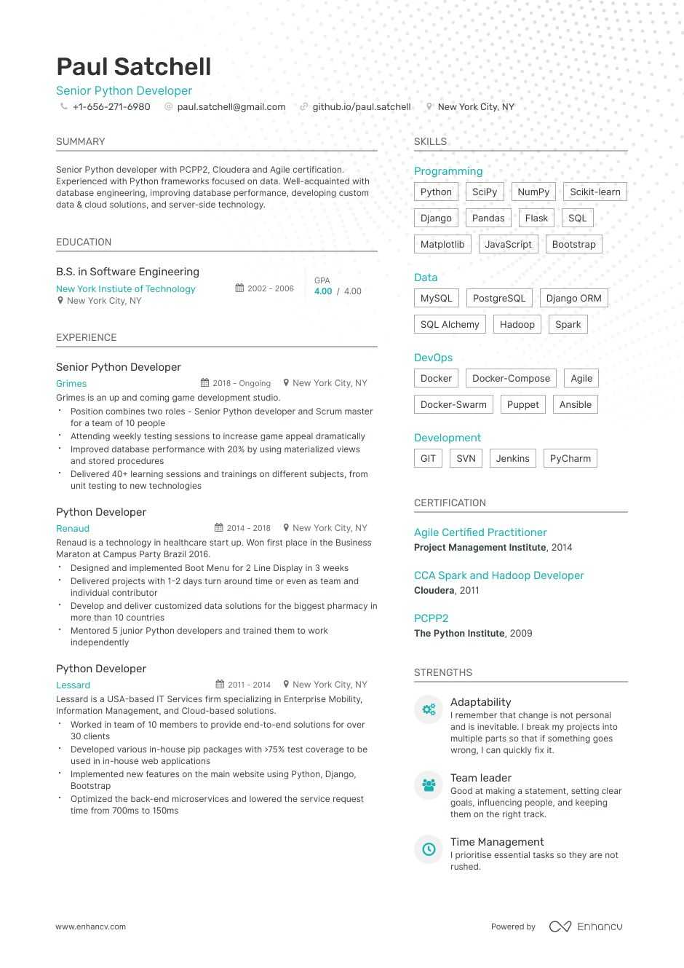

Junior Python developer resume

[**USE THIS TEMPLATE**](https://app.enhancv.com/resume/new?example=python-developer_junior-python-developer)

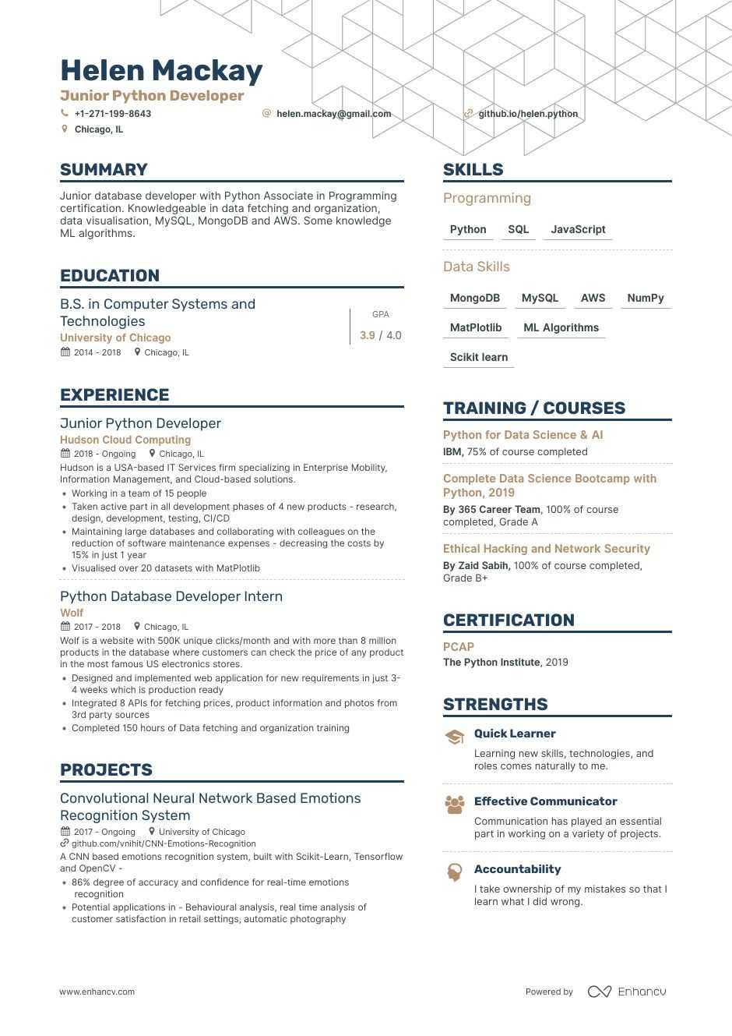

Feeling inspired?

Great!

Let’s now start writing your resume!

**How to write a great Python developer resume?**

When someone is going to spend as little as a few seconds judging your resume, you can’t afford to send across a cluttered, vague and irrelevant resume.

You saw that one page resume trending on Hackernews.

The two worded feedback from an anonymous Redditor said simply that your “resume sucks”.

Did you find that advice helpful at all?

No, right?

Because, that information was for a specific context, specific experience and may even be specific to a job.

In reality,

Entry level Python resumes have everything from C++ to Node.js listed in them. Making a recruiter feel that the resume is irrelevant.

Most senior Python dev’s resumes continue to contain the same old junior python dev content with a bit more information in the experience section.

What that tells you is that your resume should have a proper layout and should be the right fit for your experience and the job needs.

2 formats for a Python developer resume:

* Reverse chronological layout - Emphasizes your work experience like a timeline
* Functional layout - More focused on your skills, and doesn’t represent your story

Reverse chronological layout is best for most of the job applications. Especially when you have some form of work experience to show as a Python developer - even if it’s a small internship.

When it comes to Functional layout, we would suggest caution. Getting a functional resume layout right takes a lot more creativity and is risk prone.

But, a format alone isn’t going to get you the job.

5 tips to write a great Python developer resume

1. Make sure to add Python frameworks, tools, project management skills within your resume.
2. Display the scale of work and quality of code you wrote.
3. Customize your resume to the job you’re applying for.
4. Remove everything that’s not relevant to the Python job you’re applying for.
5. Add your achievements, research papers, publishing and your open source projects.

Let’s now start building these resume sections.

The first section that we will look into is the resume header.

Writing a good Python developer’s resume header

Imagine a recruiter going through your resume header.

They see your name, then a bunch of information and then moves on to other sections.

And, that’s when you lost a huge opportunity to impress them.

Examples of good and bad Python resume header

**MARK L. SAUNDERS**

**Junior Python Developer**

**3111 Baker Avenue, Fort Worth, TX, Texas**

**WRONG**

**MARK L. SAUNDERS**

**Junior Python Developer**

**github.com/markl, aunders.com**

**Fort Worth, TX**

**RIGHT**

The second example has been designed to perfection to make sure that hiring managers gets to know the best of you.

Imagine applying at a big name org as a junior Python dev. Now, if a recruiter opens your GitHub profile and sees that “green” heatmap throughout the year. You’ve made your impact!

That’s why you shouldn’t leave any space for errors, and should make sure to follow the basic resume header design.

As a rule of thumb, you should always include the following to your resume summary:

* Name
* Phone number
* Email
* Location (not your actual address)
* Your GitHub profile
* Your website (if you maintain one)

Writing a good Python resume objective or summary

Let’s first establish one thing - you are writing this resume for someone else to read.

When you write a resume summary without thinking what a recruiter wants, you write to boost your own ego and end up adding irrelevant stuff to your resume.

Here’s what a recruiter might look for in your resume summary:

* The total work experience - don’t make them add up broken chunks of Feb 2011-Jan, 2013 + Jan 2013-June 2016, etc
* Python frameworks you’re familiar with
* Whether you are a junior or senior dev
* Your passion or area of focus e.g. Financial applications, data pipelines, etc.

The word out there is that resume summary only applies to professionals that have a work experience.

**SUMMARY**

We live in the era of MOOCs, GSocers, Kagglers, just to name a few. And it is not uncommon to find an entry level Python developer who has never worked for anyone, but has knowledge and capabilities that are equivalent to that of a 5-year experienced dev.

**WRONG**

Don’t let the lack of experience discourage you from writing an impactful resume summary.

Examples of good and bad resume summaries

Bad resume summary example

**SUMMARY**

To be associated with a progressive organization that provides an opportunity to apply my knowledge and Python skills in order to keep abreast with the latest trends and technologies.

**WRONG**

A good resume summary should look something like this:

**SUMMARY**

A Python developer with 5.8 years of experience in Django, Flask for Retail eCommerce, POS and Storage domain. Received SPOT Award and Best Scrum Team while working at Walmart.

**RIGHT**

In a nutshell, a good Python summary should:

* List your total Python experience
* Show what you’ve done with Python (projects/ industry/ application category)
* Mention if you’re a recognized speaker or if you maintain a local Python chapter
* Should mention if you have received any special awards
* Should contain notable open source project(s)

Resume summaries can also be incredibly powerful when you’re applying for a better position or are building a career change resume.

**How to include Python experience on your resume**

Honestly, a Python developer’s resume experience can easily be a book. But, no one except you is going to read that.

A few things to consider while writing your resume experience section:

* List what projects were done during your current and past employment
* Explain what technology stack was used (languages, frameworks, tools)
* Mention how you handled testing/Continuous integration/devops
* List the scale of the projects (number of customers, requests per second, read writes to database, LOC, etc.)
* Mention if you were responsible for the architecture and team management

This resume experience should be tweaked based on:

* Whether the job requires someone to do very specific things like “database modelling and design” or whether they want someone more generic.

For example, someone applying for a job that asks for specific things could involve an experience like:

Database modelling and design for a Walmart and end to end implementation of the warehouse application using Flask. My roles and responsibilities included:

* Database design and modelling to handle 100M requests per day
* Built API handling interfaces to add a layer of abstraction between Product APIs and 100s of customer APIs
* Built efficient record keeping with consistency and scale using a mix of MySQL, MongoDB and PostgreSQL clusters

Notice how the resume experience mentions database design and modelling? That’s what a hiring manager would notice too!

Examples of good and bad python resume experience

Let’s say you’re going to send your resume to Mark, the (fictional) Head of Development for Intercom. You wrote your resume experience like this:

**EXPERIENCE**

Sr Python developer**Atlassian**

[**02/2015 - 11/2017**](https://enhancv.com/resume-examples/python-developer/)

San Francisco, CA

Built an API-driven publishing service that delivered high performance.

Responsible for clearing performance bottlenecks in Mercurial for large-scale deployments.

Wrote the module for source control query service.

Ensured to remove large repository challenges.

Rebuilt the mercurial sparse subsystem.

**WRONG**

What do you think would happen if Mark reads this? He’ll know what you worked through APIs, wrote some modules, etc. but nothing here that would tell him about the scale of your work, the impact you made or the team size you worked with.

Let’s try to write it a bit better.

**EXPERIENCE**

Sr Python developer**Atlassian**

[**02/2015 - 11/2017**](https://enhancv.com/resume-examples/python-developer/)

San Francisco, CA

Built an API-driven publishing service handling 17 million pageviews per month performing at 94% cache efficiency

Cleared several performance bottlenecks in Mercurial for large-scale deployments

Build out the source control query service that queries information in a scalable and efficient manner

Extended the build system to integrate with the mercurial sparse feature cutting down on performance issues with overly large repositories

Rebuilt the mercurial sparse subsystem to move it from an implementation detail to an end-user-friendly tool

Mentored 5 junior Python developers and trained them to work independently

**RIGHT**

Notice how the rewrite helps you stand out?

But, what if you aren’t applying to a job that demands wearing multiple hats and a lot more work than a traditional Enterprise role?

On average, a Python developer handles more than 10 responsibilities and handles 5+ projects (big and small) in a year. To make sure you write the best work experience here, you need to pick your best 5 that makes the cut.

**EXPERIENCE**

Lead Python Developer**Plemento**

[**01/2015 - 12/2018**](https://enhancv.com/resume-examples/python-developer/)

San Francisco, CA

Responsible for the entire development of our Plemento’s SaaS offerings.

Managed a team of 4 devs and reported to the CEO.

Implemented MVC framework for Plemento.

Wrote and executed various MySQL database queries from Python using Python-MySQL.

Responsible for debugging and troubleshooting the web application.

**WRONG**

**EXPERIENCE**

Lead Python Developer**Plemento**

[**01/2015 - 12/2018**](https://enhancv.com/resume-examples/python-developer/)

San Francisco, CA

Designed architectures for all Plemento products and scaled them to beyond 1M users per month.

Implemented dev automation using Docker, Jenkins CI and test automation tools.

SDLC - Acted as the Scrum master managing onsite and offsite remote teams.

Introduced pair programming, architectural patterns and code quality reviews to reduce tech debt.

Reduced lead time for new feature requests down to 30%.

Managed a codebase of 250,000 LOC.

**RIGHT**

Adding these resume points to your resume would lead to a winner resume for sure.

But, what if the job demands someone with a breath of experience? You have limited real estate on resume summary and experience sections.

The best way to add should more Python skills is by listing down on a Python resume skills section.

**27 important Python resume skills that you may want to add**

You have some (or all?) of them. All you need is a little inspiration. So, here’s a list of technical and soft skills that you might want to add to your resume:

22 Technical skills for your Python resume:

1. Python
2. Django
3. Flask
4. Tornado
5. Git
6. SQL
7. AWS
8. Azure
9. Linux
10. MySQL
11. MongoDB
12. PostgreSQL
13. Apache
14. Bash Scripting
15. Javascript
16. HTML/CSS3
17. OpenCV
18. Machine learning
19. Numpy
20. Scipy
21. Front end frameworks (Angular, React, Knockout)
22. Unit testing (unittest, pyunit, etc)

Soft skills that you should consider adding to your resume:

* Communication
* Team leadership
* Presentation skills
* Collaboration
* Research

When it comes to soft skills, too many underestimate what soft skills they really have.

If you happen to be stuck in such a situation, just run this list by a couple of your colleagues/friends and see what they feel.

**Python projects, awards, and recognitions within your resume**

Awards and certifications

* Cloudera Certified
* PCI Compliance Level 3
* Pycon 2019 Keynote
* Numpy core contributor

When a recruiter looks at this, they know for sure that this isn’t just an ordinary resume.

If you’ve worked hard, made open source contributions or launched a repo that went big on GitHub - you should add this section in your resume.

You’d be surprised to see how few resumes actually have this section.

Now, no one is going to tell you that they tossed off your resume just because you didn’t have an “awards” section in it.

When it comes to a resume design, lack of these sections leads to reduced confidence, and subsequent rejection. It’s something no one can easily point out, but can feel.

Your final takeaways:

* Focus on building a reverse chronological resume.
* Write a resume header that has the right contact information and links to your portfolio.
* Reflect your passion, achievements in your resume summary.
* Write a work experience that makes your resume memorable.
* List your awards and certifications in a separate section.

NAME xx xxxxx xxxxxxxx

(+91)-xxxxxxxxxx.

Objective A results-driven, customer-focused, articulate and analytical Software Engineer who can think “out of the box”. Strong in design and integration problem solving skills. Expert in Python with database analysis and design. Skilled in developing business plans, requirements specifications and User documentation. Strong written and verbal communications. Interested in a challenging technical track career in a development environment.

Core Competencies

· 6 years of IT experience in architecture, analysis, design, development, testing and support of web based and client/server applications using Python.

· Extensive experience in Python, PHP, Mongodb, AJAX, HTML, CSS and JavaScript.

· Sound knowledge of object-oriented concepts, analysis and design of applications architecture. Worked on high level design, low level design, and key components development in various projects.

· Strong experience in version control systems like GIT, SVN

· Wide exposure in Domain Analysis for OO design and Implementing design patterns.

Technical Skills:

· Languages : Python(2.7) , PHP, c# .NET, TAL, Java Script, Ajax

· Platforms : Linux, Windows

· Database : MSSQL, Postgre-sql, MongoDB

· Tools : Dreamweaver, Putty, WinSCP, VMware Workstation, GIT

· CMS : Plone

· Others : CSS, Zope Application server, JSON, XML, Bottle Framework, Apache, Maven

Educational Qualification:

· Masters In Computer Application from SMU in 2013

· BSC in Information Technology from Kuvempu University in 2009

· Intermediate in science from BIEC in 2005

· Matriculation from JSEB in 2003

Professional Qualification:

GNIIT in Software engineering 3 years Diploma from [COMPANY NAME], New Delhi

Employment History

Organization Designation From To

COMPANY#1 CONSULTANT 29 Sep 2014 Till Date

COMPANY#2 SENIOR SOFTWARE DEVELOPER 07 Jul 2010 25 Sep 2014

COMPANY#3 WEB DEVELOPER 25 May 2009 06 Apr 2010

Project Details

Project Boeing ECFD

Client Boeing

Duration 10 Months

Team Size 10

Role/Position Technical Consultant – Senior

Project

Description The eCFD application is being developed to establish a common process and decision tree based set of tools to execute CFD across the enterprise. The vision of eCFD is to develop a System (Platform) that will facilitate the end users (engineers) to plan, setup, execute and analyse the results · The plan phase provides an interface to plan the entire process, such as defining creation of plan, identifying the process, capturing the configuration files and conditional matrix details and identify the deliverables. · The setup phase provides an interface for creating storage hierarchy for the project files. · The execute phase provides an interface to retrieve for existing retrieve existing configuration, generate discretization and solver inputs and execute the solver. · The analyse phase plots the output from the execute phase in the form of graph for further analysis. The ECFD system is also responsible for invoking program, scripts and tools for carrying out various operations in ECFD process. · The archive phase stores the processed data for the future review and usage. · The ECFD is intended to be used for Commercial and Fighter Aircrafts.

Technical

Environment Python and Windows/Linux, Bottle, Apache, Mongodb

Responsibilities · Requirement gathering, Developing based on requirements and Closely work with solution architects · Involved in Design and development of Backend services. · Developed Backend services in Python and exposed the same to other layers · Developed Backend python scripts and wrote no SQL queries in mongo to store and retrieve data · Involved in environment setup and Integration at the client environment and worked on Apache configuration.

Project eOffice Portal

Duration 20 Months

Team Size 10

Role/Position Senior Software Developer

Project

Description eOffice Portal is one of the Mission Mode Projects (MMP), under the National e-Governance Plan (NeGP). The project is aimed at significantly improving the operational efficiency of Central Government Ministries and Departments through improvement in the workflow mechanisms and associated office procedure manuals. eOffice Portal also aims at quick access at a systematic approach to storage, retrieval, communication, integration and publication of information available in different formats such as documents, statistics etc

Technical

Environment Python 2.7 HTML POSTGRES SQL

Responsibilities writing python script for backend development

Project eOffice Services

Duration 16 Months

Team Size 3

Role/Position Senior Programmer

Project

Description Website for eOffice Portal Description and Registration Process

Technical

Environment Python, Postgres Sql

Responsibilities Design And Development

Project eOfficeServices IGR

Duration 8 Months

Team Size 2

Role/Position Programmer

Project

Description Website for Infra Gap Report

Technical

Environment PYTHON,POSTGRES SQL,HTML,JAVASCRIPT

Responsibilities Design and Development

Project EOPD HRM

Duration 10 Months

Team Size 1

Role/Position Programmer

Project

Description Website for complete human resource management solution

Technical

Environment PYTHON POSTGRES SQL

Responsibilities Design and Development

Project Apeeda Bulk Entry Software

Duration 11 Months

Team Size 5

Role/Position Web Developer

Project

Description Software for bulk entry into database using asp.net

Technical

Environment Dot Net And Sql Server

Responsibilities Developer

Personal Details

Name: ******** Father’s Name: ******** Date Of Birth: dd mm yyyy Email: ******@gmail.com

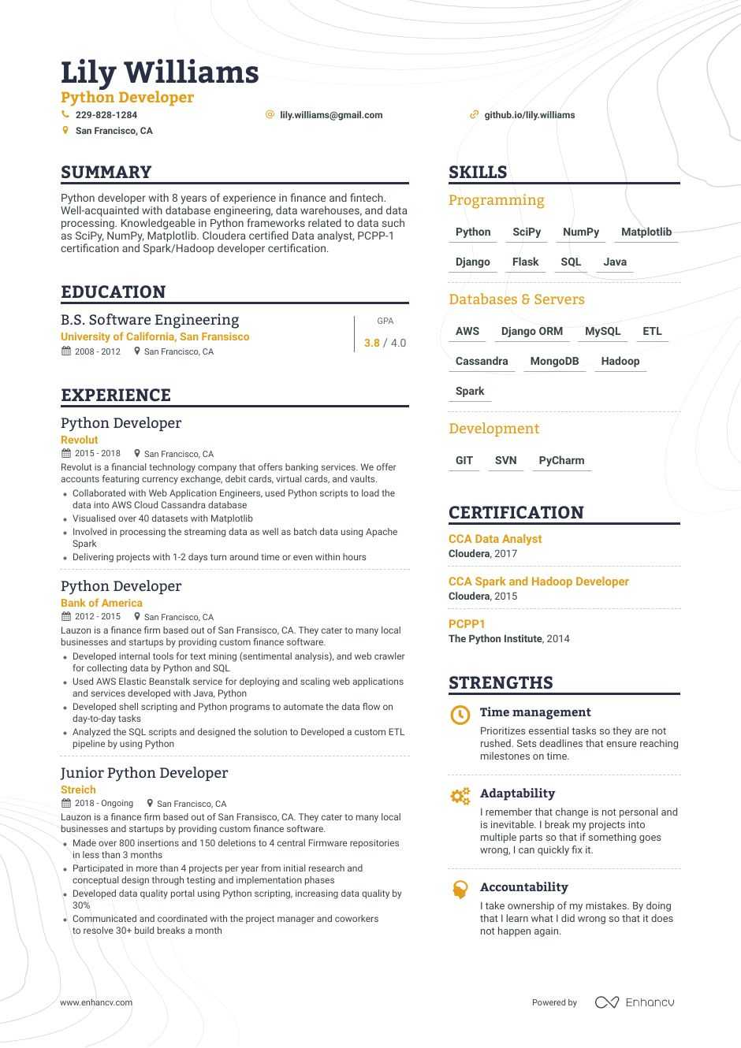

**Senior Python Developer / Team Lead**

Designed and developed integration methodologies between client web portals and existing  
software infrastructure using SOAP API's and vendor specific frameworks.

* Created RESTFUL API's for several of our Intranet applications using open source sof tware
* Managed a small team of programmers using a modified version of the agile development
* Designed and developed corporate website using the D jango framework
* Designed and developed a corporate intranet that is used in daily work flow to increase
* Created multiple advertorial pieces from concept and managed small advertising campaigns
* Managed windows servers which included Active Directory maintenance and support
* Created a work flow using technologies such as GIT/SSH to develop multi -programmer

**summary**  
9+ years of experience as a Python Developer, proficient coder in multiple languages and environments including Python, RESTApi, AWS, C, C++ and SQL.Bottom of Form

* Excellent working knowledge in UNIX and Linux shell environments using command line utilities.
* Highly motivated, quality minded developer, with proven ability to deliver applications against tight deadlines.
* Possess good interpersonal, analytical presentation Skills, ability to work in Self - managed and Team environments.
* Performed code reviews and implemented best Pythonic programming practices
* Experience in writing test scripts, test cases, test specifications and test coverage.
* Good experience in handling errors/exceptions and debugging the issues in large scale application

**Confidential, Los Angeles, CA**

**Senior Python Developer**

**Responsibilities:**

* Developed entire frontend and backend modules using Python on Django Web Framework.
* Worked on designing, coding and developing the application in Python using Django MVC.
* Experience in working with Python ORM Libraries including Django ORM,
* Worked on integrating python with Web development tools and Web Services.
* Wrote and executed various MYSQL database queries from python using Python MySQL connector and MySQL dB package.
* Wrote scripts in Python for extracting data from HTML file.
* Utilize PyUnit, the Python Unit test framework, for all Python applications.
* Performed troubleshooting, fixed and deployed many Python bug fixes of the two main applications that were a main source of data for both customers and internal customer service team.
* Rewrote existing Python/Django modules to deliver certain format of data.
* Wrote python scripts to parse XML documents and load the data in database.
* Used Python and Django to interface with the jQuery UI and manage the storage and deletion of content.
* Worked on several python packages
* Proficient in developing Web Services (SOAP, RESTful) in Python using XML, JSON.
* Experience in implementing and working on the python code using shell scripting. Performed troubleshooting, fixed and deployed many Python bug fixes.
* Implemented REST APIs using Python and Django framework.
* Developed web-based applications using Python, Django, XML, CSS, HTML, JavaScript, AngularJS and jQuery.
* Worked on WAMP (Windows, Apache, MYSQL, Python/PHP) and LAMP (Linux, Apache, MySQL, Python /PHP) Architecture.
* Developed views and templates with Python and Django's view controller and templating language to created user-friendly website interface.
* Review Requirement, develop technical design documents and create a prototype of the critical business application using JAVA/J2EE Initiated use of HttpUnit, Selenium IDE for testing.
* Worked with J2EE and J2SE technologies including JSP, Java Web Start, and Weblogic.
* Design and develop new features in website using Java/J2EE under Santana Framework and enhance existing features. Refactoring code, redesign current design.
* Working on Java/J2EE framework APIs like Spring, iBatis and Hibernate.
* Used Java/J2EE Design patterns like Business Delegate and Data Transfer Object (DTO) in the project which facilitates clean distribution of roles and responsibilities across various layers of processing.
* Prepare Java/J2EE development structure for Rational Application Developer.
* Developed front end using Angular.js, React.JS, Node.js, bootstrap.js, backbone.js, JavaScript, where back end is java with REST webservice.
* Worked on the MySQL migration project to make the system completely independent of the database being used. Used Spring IBatis to implement this.
* Created a Rich Single Page Application using HTML, CSS, JSP, JSON, Angularjs, React.js, Node.js, bootstrap.js, backbone.js.
* Created Oracle database tables, stored procedures, sequences, triggers, views
* Create new PL/SQL stored procedures for new Oracle Forms and Reports development
* Web development including standardizing the toolsets used from Eclipse to using Git for source control
* Used Github repository for version control.
* Created and deployed web pages using HTML, JSP, JavaScript and CSS.
* Developed Web based Dynamic Form Builder using HTML, CSS, JavaScript Object-to-XML.
* Used REST WebServices for creating rate summary and used WSDL and SOAP messages for getting insurance plans from different module and used XML parsers for data retrieval
* Consumed Restful Webservices where the transmission of data is in JSON format.
* Designed and Developed REST WebServices to interact with various business sectors and used SOAP protocol for webservices communication
* Extensively worked on Application servers like Weblogic and Apache Tomcat